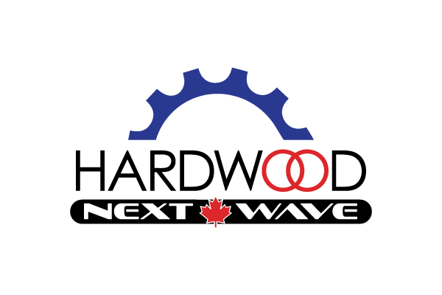

Rider Contract 2023

Name:

Athlete Mobile: Parent Mobile:

The following "Code of Conduct" flows from the values and ethics espoused by Cycling Canada, and will be used by The Next Wave Cycling Team. The Next Wave Cycling Team is committed to providing "the pursuit of good sport" and ensuring that the sport of cycling is practiced in a fair manner. The Code of Conduct is a specific description of the behaviour we expect from athletes involved in The Next Wave Cycling Team.

At hle te S tateme nt

I believe that the true essence of sport is to strive for personal achievement and excellence through full and honest effort. I am committed to participating in sport with integrity, and to strive to win only by legitimate means. I pledge to learn, understand, and adhere to both the written rules of my sport and the accepted rules of fair play. I understand that Officials, team- mates, and opponents are all integral to this sport and worthy of my respect. It is my responsibility to maintain self-control. I will accept Officials’ and Coaches decisions without arguments, play aggressively but without hostility, and behave graciously in triumph or defeat.

CCode of Conduct

Res pec t for othe rs

- I agree to act with respect toward all those I come into contact with. This means I will refrain from comments or behaviours; which are abusive, offensive, racist, sexist or otherwise belittling or demeaning to others.
- I do not harass or tolerate harassment by others.
- I respect others as persons and treat them with dignity.
- I respect the privacy of others.
- I do not endanger the safety of others through my actions.

RRespect for Self

  - I act with fairness and integrity in the pursuit of excellent sport.
  - I accept True Sport and Race Clean, Own your Victory principles and practise drug-free sport and accept doping control.
  - I avoid the abuse of alcohol, illegal drugs and Sport Enhancing Substances.

Res pec t for S port

- I strive for personal excellence in sport.
- I honour and respect the spirit and traditions of sport.
- I do not impede the preparation for competition of other competitors or team-mates.
- I respect the decisions of judges and officials and team staff.

Res pec t for the Sport of C yc li ng

- I accept the UCI/CC/OCA’s rules, policies and procedures governing events and competitions in which I participate.
- I accept that I am an ambassador for the sport of Cycling, The Next Wave Cycling Team and its Sponsors.
- I refrain from any action which might bring the sport of Cycling,
The Next Wave Cycling Team and/or its Sponsors into disrepute.

Res pec t for P rope rt y

- I respect the property and livelihood of others, which means refraining from vandalism, theft and other forms of mischief.

Sponsors hip Re quireme nts

I understand that I am receiving products and support from The Next Wave Cycling Team and it's Sponsors, in return:

- I understand that I am required to hold a UCI/Citizen License with Hardwood Next Wave Cycling listed on the OCA site as a private cycling team.
- I will NOT disclose the discounted prices I receive as part of my sponsorship
- I will wear custom kit/sponsor products provided on the podium and at all Road, MTB and CX events
- I will return any team kit provided in 2023 to The Next Wave Cycling Team manager,
if removed from the team for disciplinary reasons. I also understand that I will not receive a refund for any portion of membership dues paid for this year.
- I understand that in order to receive any discounts through the club’s sponsors, I must remain a member in good standing,
- I understand that I will be required to participate in certain promotional/team fundraising events throughout the year that are separate from the race schedule (ie. fundraising, team rides, events, races, photo shoot.)
- When posting about Team activities on social platforms, consideration will be given to our sponsors appropriately.

Risk Management Plan

I have read and will abide by The Next Wave Cycling Team Risk Management Plan.

Liability Statement

I acknowledge that I have read this agreement and understand it, that I have executed this agreement voluntarily, and that this agreement is to be binding upon myself, my heirs, spouse, children, parents, guardians, next of kin, executors, administrators and legal or personal representatives. I further understand that by becoming a member of The Next Wave Cycling Team I am bound to the terms of the CANADIAN CYCLING ASSOCIATION: WAIVER, RELEASE and ASSUMPTION of RISK AGREEMENT.

Promotional Material

I agree to allow Next Wave Cycling or any agent of the Team to include my photograph, video, recorded audio or comments in any promotional material used in the marketing of our Team without liability or compensation.

Refund Policy

Members are not provided with any form of refund for unused portions of the program.

Signature below acknowledges that the Member has read, understands and agrees to abide by The Next Wave Cycling CODE OF CONDUCT as outlined above

Signature of Rider __________________________________________________

Print Name ________________________________________________________.

Signature below acknowledges that the parent/guardian has read, understands and agrees to also abide by The Next Wave Cycling CODE OF CONDUCT as outlined above.

Signature of Parent/Guardian__________________________________________.

Print Name ________________________________________________________

Date ______________________________________

Parent E-mail_______________________________________________________

